**CVSU-SC COMPUTER LABORATORY TROUBLE TICKETING SYSTEM**

**John Erick M. Bauyon**

**John Michael N. Lamadrid**

An undergraduate thesis manuscript submitted to the faculty of the Department of Information Technology, Cavite State University – Silang Campus, Silang, Cavite in partial fulfilment of the requirements for the degree Bachelor of Science in Information Technology with Contribution No. DIT-BSIT-2019-02-022. Prepared under the supervision of Mr. Erwin L. Cahapin

**INTRODUCTION**

Manual process of reporting issues usually takes time before the actual problem is resolved by the technician or staff. According to Ambrose A. Azeta, the problems of manual system includes: time wasting to get ICT problems solved and slow response on the part of ICT support staff. The process of reporting a physical ICT problem to the helpdesk center is cumbersome and stressful. Paper forms have to be filled and official memos has to be written and submitted to helpdesk department before receiving attention.

A ticket (also known as an incident ticket or trouble ticket) is a file, usually contained within an issue tracking system which contains information about support interventions made by technical support staff, or third parties on behalf of an end user who has reported an incident that is preventing them from working with their computer as they would expect to be able to.

The program sends ticket created by the user that will notify the it staff and this ticket can be modified by the staff. After the IT staff takes action to the issue, he can mark the ticket as complete and provide details of his actions and the user will receive notification in the program about the ticket.

**Statement of the Problem**

By conducting an interview to the IT staff of CvSU – SC, the developers found out that it takes time for the technicians to fix issues in computer laboratory of the school because users need to manually visit the IT support staff or contact them to report specific problem and to check on its status.

The study focuses on ticket management support for computer laboratory in silang campus. Specifically, it will seek to solve the following problem: Manual reporting of computer related issues in computer laboratory of CvSU - SC.

**Objectives of the Study**

The general objective of the study is to develop Cavite State University Silang Campus computer laboratory trouble ticketing system.

Specifically, this study aimed to:

1. To design a ticketing system for computer laboratories of Cavite State University Silang Campus with the following features:
   1. Log-in/authentication for admin and user
   2. Window forms for user and admin to work with.
   3. Data entry and display of tickets.
2. To construct the program using the following development tools;

2.1 Visual Studio 2015

2.2 Bunifu framework

2.3 Xampp 3.1.2

1. To assess the performance and acceptability of the developed application using the evaluation instrument ISO 9126-1.

**Significance of the Study**

The beneficiaries of the project are IT staffs and IT instructors. The study focuses on improving the productivity of IT staffs through a ticket management system. The system will help the users to track all events, failures, and issues occurred in the campus computer laboratory. IT staff can assign actions and priority to the tickets; users will be notified about the status of the ticket easier.

**Time and Place of the Study**

The development was conducted in Cavite State University – Silang Campus. It was conducted from April 2018 to May 2019.

**Scope and Limitations of the Study**

The system was intended to facilitate effective issue management by giving it a priority respectively, analyzing it, and providing actions needed. A ticket supports various statuses such as: new, work in progress, due today, and completed. It also has different priorities as: low, high, and urgent. Both status and priority are configurable. The application also supports E-mail notification for recovering accounts.

However, the system is only intended for computer laboratories of CvSU Silang, and only focuses on issue tracking / incident management for the said laboratory. The system does not have a save option of report to save to cloud storage.

**Definition of Terms**

**CvSU-SC Computer Laboratory Trouble Ticketing System** refers to the system used to track and organize issues in the laboratory.

**Analysis** refers to the collected data that has been analyzed.

**Bunifu**refers to the framework used to design the UI of the system.

**Computer based** refers to the used of any kind of learning with the help of computers.

**Data Collection** refers to the action or process of collecting data from the user in any form.

**Developmen**t refers to the consolidation of all the phases undertaken to finish the project.

**Tickets** refers to a support request that has a unique ID from a user. Is stored and managed in the ticketing system to be handled by the admin.

**Ticketing System** refers to support system used by customer service to receive, store and manage tickets.

**Conceptual Model**

On the basis of the foregoing concepts, theories, and findings of related literature, studies presented, and insights taken from them, a conceptual model is develop as shown below:

**INPUT PROCESS OUTPUT**

Evaluation

(Adopted ISO 9126-1)

**Knowledge Requirements**

1. Network management
2. Problems encountered in computer laboratories
3. Visual Basic

**Software Requirements**

1. Visual Studio
2. Bunifu Framework
3. Xampp for MySQL database server
4. Microsoft Word

**Hardware Requirement**

Computer with the following specifications:

1. Dual core processor
2. 4 GB Ram
3. 160 GB Hard Disk

a. Planning

b. Analysis

c. Design

d. Implementation

e. Maintenance

**CvSU – SC Computer Laboratory Ticketing System**

Figure 1. The Conceptual Model of the Study

The input block includes the basic requirements of developing the system which includes knowledge requirements, software requirements and hardware requirements. Knowledge requirements refer to the principle and resources that are to be used in order to develop the CvSU- SC Computer Laboratory Ticketing System. This includes complete understanding and knowledge about the ticket management system, the problems encountered in computer laboratories, the ticketing system itself and the different languages to be used in the development as well as the database. The software requirements refer to the different computer applications and software that was used in developing the system. These requirements include Visual Studio for the system development,Bunifu framework for system design, Xampp for MySQL database server, Microsoft Word for documentation. Hardware requirements refer to the hardware specifications of a computer needed to develop the system. The computer must have the following minimum specifications: a dual core processor, 4 GB RAM and 160 GB hard disk drive for a smooth and lag-free coding and system running.

The process block refers to the actual development stage of the study. It includes system design, particularly making the context diagram, data flow diagram and database, construction which involves program coding and lastly, the implementation of the output.

After the development and implementation of the Ticketing System for Computer Laboratories of CvSU-Silang, the final output was evaluated using the criteria of ISO 9126-1.

**REVIEW OF RELATED LITERATURE**

In this section, the ticketing system information was presented and discussed. It also discussed the importance of ticketing system in an organization. It presents researches on how the ticketing system works. The findings of previous studies are reviewed and their relevance to the current research is considered.

**Service desk**

Ticketing system is a key function of Service operation as defined in the Information Technology Infrastructure Library (ITIL). According to ITSMF, “ITIL is a public framework that describes best practice in IT service management. It provides a framework for the governance of IT, and the management and control of IT services.” One part of an IT service life cycle defined in ITIL is Continual service improvement which is seven-step process based on Deming PDCA cycle.

The work of Jäntti and Kalliokoski (2014) may be mentioned as an example of a practical way of improvement. They identified challenges by interviewing service desk staff with carefully chosen questions. Challenges were related to incident classification, automation of incident and order processes, quality of staff instruction documents, and escalation of the incident to the higher level.

**Trouble Ticket Routing**

A critical challenge for the ticket management system is how to quickly deal with trouble tickets and fix problems. Thousands of tickets, bouncing among multiple expert groups before being fixed, will consume limited system maintenance resources and may also violate the service level agreement. Thus, trouble tickets should be routed to the right expert group as quickly as possible in order to reduce the processing delay. The quality of modern large-scale IT service delivery highly depends on the underlying IT infrastructure. Although powerful hardware and software tools have been used in modern IT infrastructure, it is still inevitably to suffer from system faults, even system failure, due to software aging operation errors, etc. When an event (which is not part of the standard operation of a service that may cause an interruption or a reduction) happens, or when using an IT service, errors, faults, difficulties or special situations (that need attention from system management experts) occur, a trouble ticket is then generated in the ticketing system. The IT infrastructure and service delivery management system is responsible for dealing with the trouble tickets in time (Zu, He, Zhou, 2018).

**Help Desk Management System**

Masongsong& Damian (2016) stated that, “help desk is a customer support center in an organization that provides information, administrative and technical supports to users, with the view to solving problems that users encountered in the course of using the organization resources or facilities”. A help desk could comprise of one person or group of persons that make use of telephone devices or software applications to keeep track of problem(s) status and thus provide solution(s) that satisfy the users as Sheehan cited. Helpdesk could also be seen as an information and assistance resource that supports the functionality of an organization by responding to users’ requests in a timely manner. It is hence, a core sector through which problems, complaints and requests are reported, managed, coordinated and resolved

**Technical support**

According to (Edward, 2016) Technical support is a problem area in all computer-related industries; the field of education is no exception. Current studies reflected only a limited examination of technical support within university settings. This study investigated the current methods of providing technical support and factors influencing technical support through examination of the current technical support services offered within the College of Education (CoE).

**Ticket Queue**

A ticket queue differs from a corresponding physical queue in terms of the amount of information available to customers. The lack of information for the number of existing customers in the ticket queue system results in naive customer abandonment behavior and worsens system performances compared to those in the corresponding physical queue. In order to close the performance gap, we propose to provide different types of information to ticket queue customers. The queuing system managers should consider this trade-off when they are providing information to customers (Kuzu, 2015).

According to Bain & Company net, a global management –consulting firm, “a customer is four times more likely to defect to a competitor if the problem is service related than price or product related”. Moreover, Lee Resources International net, a general business consulting stated that for “every customer complaint there are 26 other unhappy customers who have remained silent”. Thus, any companies need a provide good services in order to attract customers to attain sustainability doing business.

**Automated Queue Management**

An automated queue management system is a system that helps service provider to manage customer in efficient way. The system can ease the customer flow management which is useful for manager of the service provider (Ahmed, 2016).

**Queueing system**

Queueing systems managed by ticket technology are widely used in service industries as well as government offices. Upon arriving at a ticket queue, each customer is issued a numbered ticket. The number currently being served is displayed. An arriving customer balks if the difference between his ticket number and the displayed number exceeds his patience level. We propose a Markov chain model of a ticket queue and develop effective evaluation tools. These tools can help management quantify the service level and identify the performance gap between the ticket queue and the conventional physical queue, in which a waiting line is formed (Xu, Gao, &Ou, 2017).

**Service Desks**

According to Dehinbo (2015), ways of achieving this include innovative products and services, operational excellence and intimate customer relationships. It should be noted that it is not until recently that organizations are beginning to take intimate customer relationships very seriously. Apart from various other reasons, one particular reason is that most individuals like to feel important and it seems natural for customers to continue to patronize organizations that treat them intimately and importantly. This however should not be at the expense of quality service and support. The availability of many competitive services makes it easy for customers to seek better services elsewhere if they sense a lack of quality service and support. But furthermore, in this digital economy where users directly access e-services such as e-commerce, online banking, etc., the growth of eservices continues. So is the need for “service desks”.

**Automated Helpdesk**

An automated helpdesk system is meant to eradicate some of the barriers of reaching the Information and Communication Technology (ICT) technical staff to carry out repairs of ICT products and services in an educational institution. The problems faced with the existing ICT user support system include time wasting, difficulty in communication, and slow response to fix ICT related faults. The objective of this study is to develop an Automated Mobile Edu-Helpdesk System (AMES) for effective information dissemination, efficient management of operations and to resolve ICT challenges in higher education (Azeta et al., 2016).

**Queuing Theory and Customer Satisfaction**

According to Brahma (2014), queuing theory is the formal study of waiting in line and is an entire discipline in operations management. This article will give the reader a general background into queuing theory, its associated terminology, and its relationship to patient satisfaction. Queuing theory has been used in the past to assess such things as staff schedules, working environment, productivity, customer waiting time, and customer waiting environment.

Ticket queues are systems that issue tickets to customers upon their arrival. Although ticket queues are preferred by many service providers, there is limited research on ticket queues, especially on customer perceptions of, preferences for, and behavior in these systems. Study results indicate that subjects generally prefer ticket queues over physical queues and have greater patience in ticket queues than they do in physical queues.

**Queue management system**

Queue management system is designed in organizing queues at service sectors like banks and post offices, which expected to have a large number of customers daily. Conventional ways of managing queues like issuing paper tickets printed with queue number lead to several problems such as paper tickets littering and also long queueing or waiting time. Therefore, this paper presents the development of a system to manage queues more efficiently and eco-friendly (Jidin, Yusof, &Sutikno, 2016)

**Queue Control**

Pasalkar, Kharade, Nikam, &Jagade (2016) stated that people nowadays spend lot of time standing in queues at different places, such as banks, Government Office, College Admission and Hospitals. the queue management system helps to provide comfort as well as fairness to customers, by allowing them to maintain their position in the queue while they are seated comfortably or engaged in constructive activity so we are developing a system Which will help to manage these type of queuing situations. In other words, customers have to wait in queue for long hours for their turn. To overcome these problems, a new way of queue management system has been introduced that is Queue Control System with notification. This new system is designed with a small interface, easily accessible with smart phones for a queue management with notifications for users. This system consists of Smartphone App that provides online tokens to users. And a server that collects data from user as well as from registered places. And server will process the data collected from user and registered places. then the result will be sent back to user the result consists of estimated waiting time, token number and it will notify user about remaining waiting time after certain intervals.

**Tickets**

Based on a study conducted by Hottum& Reuter (2014), the customer contribution factor can help to reduce the unbalanced utilization of service agents by assigning tickets to agents that are able to handle them properly. By applying information about their customers, providers could be able to save resources and time internally and – at the same time – serve their customers more individual, faster and with no more effort.

Managing task or service is so important to build good relationship between users and the organization. This literature review shows that without a proper task management, it will take too much time to solve a problem and also without a system that manage task, it will be hard for the user to monitor the current status of the service. It also states here that automating the queueing system will be a big help for the service provider to manage the service to be rendered to the user more efficiently.

**Synthesis**

This literature review shows that the developers found out that there are many

existing literature reviews, studies and researches about how to manage issues encountered by helpdesk in a company. Therefore, the developers concluded that the information collected will help the future researchers to sustain the topic about issue management using trouble tickets.

**METHODOLOGY**

This chapter presents the research deign, project design, software development, population and sampling technique, respondents, instrumentation, respondents of the study, and data gathering procedure.

**Research Design**

A descriptive development approach was employed in the study. The purpose of descriptive research design is to describe characteristics of a population (Almeida et al., 2016). In this particular study the purpose was to obtain and present facts regarding software quality criteria on computer-based development. The system was further validated by instructors of the campus and IT experts from the IT industry.

**Research Methods**

The first step the proponents did was to gather data from the it staff of CvSU – SC about the problem being encountered by them in terms of resolving the issues on the computer laboratory of the campus. The data gathered was documented so that it would be easier to use. The next step is to develop the system by using VB programming language, and MySQL. Lastly, several tests were made by the proponents to make sure that the system is working properly.

The system was developed using the modified waterfall which includes five distinct phases such as Planning, Analysis, Design, Implementation and Maintenance.

MAINTENANCE

IMPLEMENTATION

DESIGN

ANALYSIS

PLANNING

Figure 2. Modified Waterfall Model

**Planning** − In this phase all requirements are gathered and prepared. The developers gathered information needed by conducting an interview to the IT staff of the said computer laboratory.

**Analysis -** The system was analyzed in order specify what hardware and software will be used develop the system.

**Design** − The requirement specifications from first phase are studied in this phase and the system design was prepared. This system design helps in specifying hardware and system requirements and helps in defining the overall system architecture.

It involves a detailed analysis of the activities related to application. They complete the analysis by creating context diagram defining the interactions between the process and data. Following the analysis, the design of the system is outlined. System procedures are designed; preliminary layouts of screens are developed. Prototypes of critical procedures are built and reviewed. A plan for implementing the system is prepared.

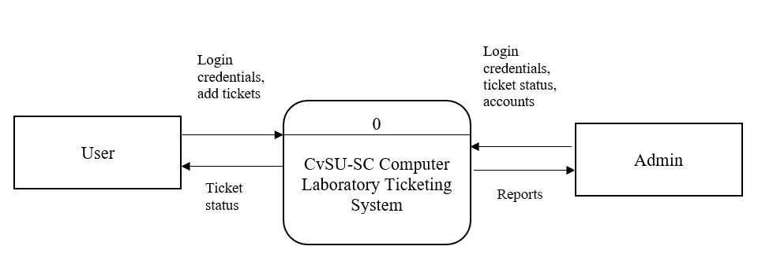

Figure 3: Context Diagram DFD of CvSU – SC Computer Laboratory Trouble Ticketing System.

Figure 2 shows how the system works. The system has two users: admin, and the user. The user needs to be registered before logging into the system. The users can view their ticket status and add tickets as well. The administrator has the overall control of the system and can modify the contents, add or delete accounts, and configure the system.

**Implementation** − With inputs from the system design, the system was first developed in small programs called units, which are integrated in the next phase. Each unit was developed and tested for its functionality, which is referred to as Unit Testing.

**Maintenance** − There are some problem which come up in the client’s environment. To fix those problems, patches are released. Also, to enhance the application for a better version are released. Maintenance is done to deliver these changes to the client.

**Population & Sampling Technique**

1. **Functional Acceptability of the System (ISO 9126-1) from the Perception of IT Experts**

The functional acceptability of the application was evaluated by thirty (30) Information Technology (IT) experts randomly selected from the industry. Thirty (30) IT experts was randomly selected from the IT industry to evaluate the functionality of the application.

1. **Functional Acceptability of the System (ISO 9126-1) from the Perception of Potential Users**

The study used non-probability of application evaluators. In this sampling design, the developers selected seven (7) users from IT department of the campus who are conveniently available. The sample population of the study was comprised of 7 potential users from a fixed quota of 37 evaluators.

**App/Study Evaluators**

IT expert evaluators of the developed application were: (a) a graduate of Computer Engineering, Computer Science, Information technology or any computer related (b) teaching IT related subjects in his field of specialization, and (c) working in the IT industry with job functions related to his field.

The user-evaluators of the developed application was taken from a sample size of DIT faculty of Cavite State University-Silang Campus. User-evaluators was taken from the sample size who meets the following criteria: (a) instructor that uses the computer laboratory.

**Research Instruments**

The study used a standard questionnaire (ISO 9126-1) for software quality. The questionnaire was modified based on the requirement of the study.

The potential user, and IT expert-respondent was requested to put a check in the column number of response mode to indicate his/her degree of agreement based on the indicators by using a 5-point scale;

5 – Excellent (E). Indicated that the potential user, content expert and IT expert-respondents perceived the required functions to be perfectly working.

4 – Very Good (VG). Indicated that the potential user, content expert and IT expert-respondents perceived the required functions are working well.

3 **–** Good (G). Indicated that the potential user, content expert and IT expert-respondents perceived the required functions are working but could be improved.

2 – Fair (F). Indicated that the potential user, content expert and IT expert-respondents perceived the required functions are working but encounters problem and needs minor improvement.

1 – Poor (P). Indicated that the potential user, content expert and IT expert-respondents perceived the required functions are needing major improvements.

The mean ratings were interpreted and describe based on their level of perceptions on the given indicators as follows: 4.20 – 5.00; Excellent, 3.40 – 4.19; Very Good, 2.60 – 3.39; Good, to some extent 1.80 – 2.59; Fair, 1.00- 1.79; Poor.

**Statistical Treatment**

The information gathered were tabulated and processed with the aid of computer to determine the precise interpretation of the results. Matrix tables were made to organize, summarize, and analyze the data gathered for easy determination of its difference from each other.

**Data Gathering Procedure**

The first step before going to the testing proper is to make a request letter. Upon approval, the developers retrieve the request letter. The request letter asked the permission of respondents to evaluate the system.

The developers looked for qualified individuals to become respondents. The developers personally administered the research instrument to the respondents. They conferred and discussed how the system works and accomplished the distribution of the instruments properly. The respondents were given 15 minutes to accomplish the questionnaire forms to prevent them from giving hasty responses. After the given time, the developers collect the accomplished questionnaires.

After the data gathering, the researcher collected it for tallying the scores and to apply the statistical treatment to be used with the study.

**RESULTS AND DISCUSSIONS**

This chapter presents the results and discussions of the objectives outlined in the previous chapter. This covers the research specific objectives stated in the introduction of the study showing the results for the objectives and what solution the developers came up with.

1. The developers designed a Computer Laboratory Trouble Ticketing System application with the following modules illustrated below:

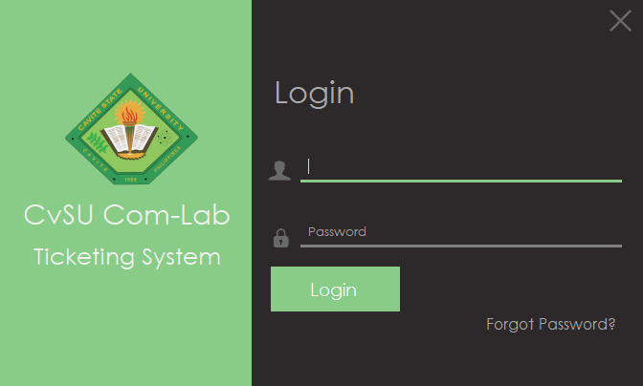

Figure 4. Log-in Form

Figure 4 displays the window log-in form of the system.

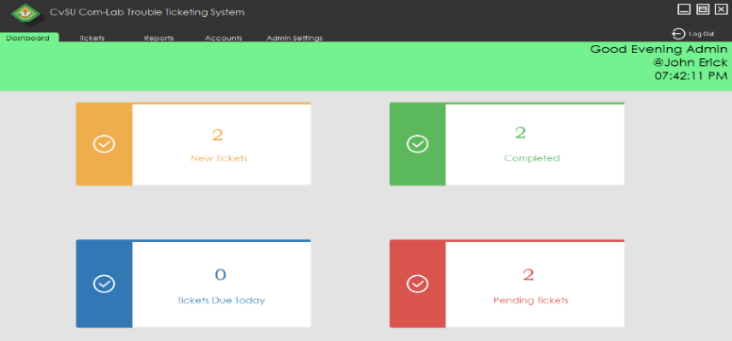

Figure 5. Admin Dashboard

Figure 5 shows the admin dashboard with the ticket status.

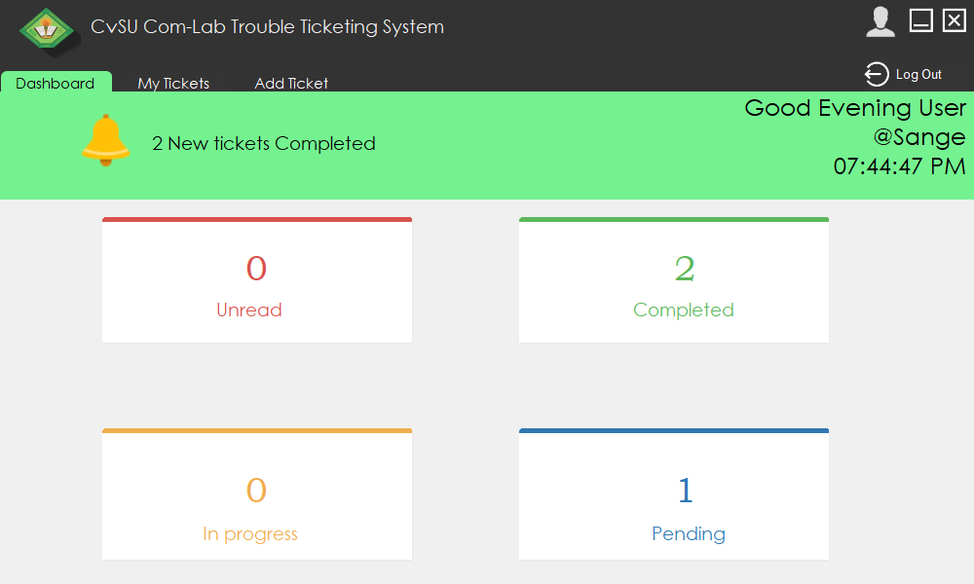

Figure 5.1. User Dashboard

1. The development and designing of CvSU – SC Computer Laboratory Trouble Ticketing System, the developers used Visual Studio 2015 for coding, Bunifu framework for creating the UI design of the system, and Xampp for the database.

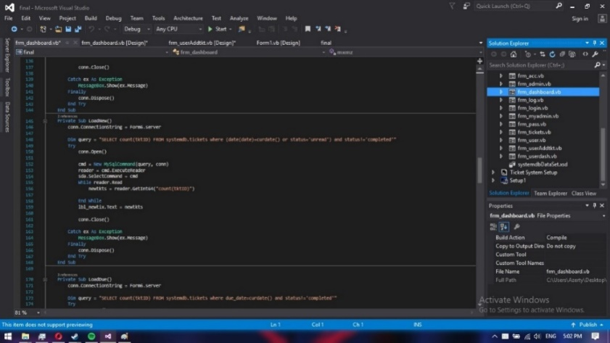

Figure 6. Visual studio 2015

Figure 6 displays the construction of the application using visual studio.

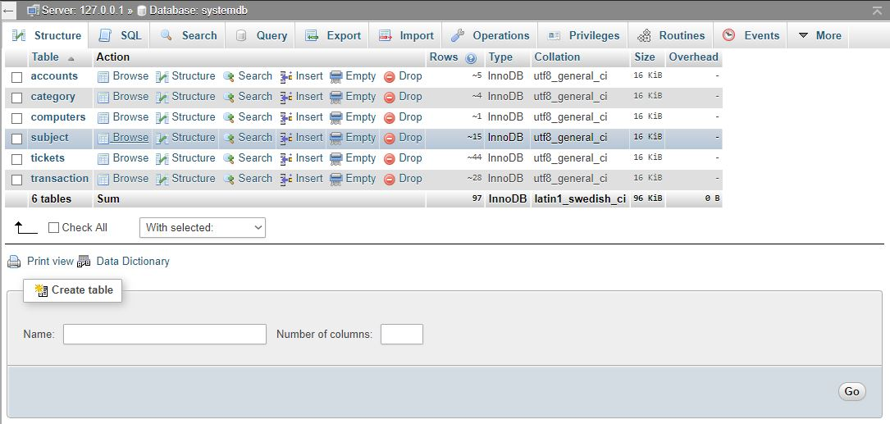

Figure 7. System Database

Figure 7 displays the database of the application.

1. The results of the evaluation are as follows:

Table 1. Functionality of CvSU – SC Computer Laboratory Trouble Ticketing System from the Perceptions of Potential Users and IT experts of the app**.**

**Indicators Potential Users IT Experts**

**M VI M VI**

1. Suitability 4.4286 E 4.4333 E

2. Accurateness 4.4286 E 4.1667 VG

3. Interoperability 4.2857 E 4.2667 E

4. Compliance 4.5714 E 4.2333 E

**Overall** 4.4286 E 4.2750 E

*Scale: 4.20 – 5.00 Excellent, 3.40 – 4.19 Very Good, 2.60 – 3.39 Good, 1.80 -2.59 Fair, 1.00 – 1.79 Poor*

*Legend: M – Mean, VI – Verbal Interpretation, E – Excellent, VG – Very Good, G – Good, F – Fair, P- Poor*

It could be gleaned from Table 1 that the Functionality of CvSU – SC Computer Laboratory Trouble Ticketing System obtained an overall mean score of 4.4286 from the potential users to denote Excellent, and, an overall mean of 4.2750 from the IT professionals with a verbal interpretation of Excellent.

The highest value of mean among the four (4) indicators is Compliance with obtained mean scores of 4.5714 to denote Excellent from the potential users. Conversely, the lowest mean scores are: Interoperability from the potential users and Accurateness from IT professionals.

The said findings complemented to the features of the application that when performing the task required, the expected result was perceive adherent to software quality standard without violating the rules.

Table 2. Reliability of CvSU – SC Computer Laboratory Trouble Ticketing System from the Perceptions of Potential Users and IT experts of the app**.**

**Indicators Potential Users IT Experts**

**M VI M VI**

1. Maturity 4.4286 E 4.1333 VG

2. Fault tolerance 4.4286 E 4.0667 VG

3. Recoverability 4.1429 VG 4.0000 VG

**Overall** 4.3333 E 4.0667 VG

*Scale: 4.20 – 5.00 Excellent, 3.40 – 4.19 Very Good, 2.60 – 3.39 Good, 1.80 -2.59 Fair, 1.00 – 1.79 Poor*

*Legend: M – Mean, VI – Verbal Interpretation, E – Excellent, VG – Very Good, G – Good, F – Fair, P- Poor*

It could be gleaned from Table 2 that the Reliability of CvSU – SC Computer Laboratory Trouble Ticketing System obtained an overall mean score of 4.3333 with a verbal interpretation of Excellent from the potential users and, an overall mean of 4.0667 from the IT professionals with a verbal interpretation of Very Good.

The highest value of mean among the three (3) indicators is Maturity with obtained mean score of 4.4286 and 4.1333 to denote Excellent and Very Good from the potential users and IT professionals. Conversely, the lowest mean score is Recoverability from the potential users and IT professionals.

The said findings may be attributed to the fact that the developed application can resume working and can function even there are faults made in the app

Table 3. Usability of CvSU – SC Computer Laboratory Trouble Ticketing System from the Perceptions of Potential Users and IT experts of the app**.**

**Indicators Potential Users IT Experts**

**M VI M VI**

1. Understandability 4.2857 E 4.3000 E

2. Learnability 4.2857 E 4.1000 VG

3. Operability 4.2857 E 4.2000 E

4. Attractiveness 4.1429 VG 4.0667 VG

**Overall** 4.2500 E 4.1667 VG

*Scale: 4.20 – 5.00 Excellent, 3.40 – 4.19 Very Good, 2.60 – 3.39 Good, 1.80 -2.59 Fair, 1.00 – 1.79 Poor*

*Legend: M – Mean, VI – Verbal Interpretation, E – Excellent, VG – Very Good, G – Good, F – Fair, P- Poor*

It could be gleaned from Table 3 that the Usability of CvSU – SC Computer Laboratory Trouble Ticketing System obtained an overall mean score of 4.2500 from the potential users to denote Excellent, and, an overall mean of 4.1667 from the IT professionals with a verbal interpretation of Very Good.

The highest value of mean among the four (4) indicators is Understandability with obtained mean scores of 4.2857 & 4.3000 accordingly to denote Excellent from the potential users and IT professionals. Conversely, the lowest mean score is Attractiveness from the potential usersand IT professionals.

The said findings complemented to the features of the application for the user can see the purpose of the application and understand how to use the application with ease, also the user see that the interface is user friendly.

Table 4. Efficiency of CvSU – SC Computer Laboratory Trouble Ticketing System from the Perceptions of Potential Users and IT experts of the app**.**

**Indicators Potential Users IT Experts**

**M VI M VI**

1. Time behavior 4.4286 E 4.1667 VG

2. Resource utilization 4.1429 VG 4.3000 E

**Overall** 4.2857 E 4.2333 E

*Scale: 4.20 – 5.00 Excellent, 3.40 – 4.19 Very Good, 2.60 – 3.39 Good, 1.80 -2.59 Fair, 1.00 – 1.79 Poor*

*Legend: M – Mean, VI – Verbal Interpretation, E – Excellent, VG – Very Good, G – Good, F – Fair, P- Poor*

It could be gleaned from Table 4 that the Efficiency of CvSU – SC Computer Laboratory Trouble Ticketing System obtained an overall mean score of 4.2857 with a verbal interpretation of Excellent from the potential users, and, an overall mean of 4.2333 from the IT professionals with a verbal interpretation of Excellent.

The highest value of mean among the two (2) indicators is Time behavior with 4.4286 mean score to denote Excellent from the potential users, while Resource utilization is the highest among two (2) indicators with a mean score of 4.3000 to denote Excellent from IT professionals Conversely, the lowest mean score is Resource utilization from the potential users and Time behavior from IT professionals.

The said findings complemented to the features of the developed application which responded just enough of time and uses the resources efficiently.

Table 5. Maintainability of CvSU – SC Computer Laboratory Trouble Ticketing System from the Perceptions of Potential Users and IT experts of the app**.**

**Indicators Potential Users IT Experts**

**M VI M VI**

1. Analysability 4.0000 VG 4.1333 VG

2. Changeability 3.8571 VG 4.1333 VG

3. Stability 4.1429 VG 4.1667 VG

4. Testability 4.1429 VG 4.2333 E

**Overall** 4.0357 VG 4.1667 VG

*Scale: 4.20 – 5.00 Excellent, 3.40 – 4.19 Very Good, 2.60 – 3.39 Good, 1.80 -2.59 Fair, 1.00 – 1.79 Poor*

*Legend: M – Mean, VI – Verbal Interpretation, E – Excellent, VG – Very Good, G – Good, F – Fair, P- Poor*

It could be gleaned from Table 5 that the Maintainability of CvSU – SC Computer Laboratory Trouble Ticketing System obtained an overall mean score of 4.0357 with a verbal interpretation of Very Good from the potential users, and, an overall mean of 4.1667 from the IT professionals with a verbal interpretation of Very Good.

The highest value of mean among the four (4) indicators is Testability with obtained mean scores of 4.1429 and 4.2333 to denote Very Good and Excellent respectively from the potential users and IT professionals.

The said findings complemented to the features of the developed application that to test the maintainability on how easy to use the application.

Table 6. Portability of CvSU – SC Computer Laboratory Trouble Ticketing System from the Perceptions of Potential Users and IT experts of the app**.**

**Indicators Potential Users IT Experts**

**M VI M VI**

1. Adaptability 4.4286 E 4.2333 E

2. Installability 4.4286 E 4.3667 E

3. Conformance 4.5714 E 4.3333 E

4. Replaceability 4.4286 E 4.3333 E

**Overall** 4.4643 E 4.3417 E

*Scale: 4.20 – 5.00 Excellent, 3.40 – 4.19 Very Good, 2.60 – 3.39 Good, 1.80 -2.59 Fair, 1.00 – 1.79 Poor*

*Legend: M – Mean, VI – Verbal Interpretation, E – Excellent, VG – Very Good, G – Good, F – Fair, P- Poor*

It could be gleaned from Table 6 that the Portability of CvSU – SC Computer Laboratory Trouble Ticketing System obtained an overall mean score of 4.4643 with a verbal interpretation of Excellent from the potential users, and, an overall mean of 4.3417 from the IT professionals with a verbal interpretation of Excellent.

The highest value of mean among the four (4) indicators is Conformance with obtained mean score of 4.5714 to denote Excellent from the potential users. From the IT professionals, the highest value of mean among the four (4) indicators is Installability with obtained mean scores of 4.3667 accordingly to denote Excellent. Conversely, the lowest mean score is Adaptability from the IT professionals.

The said findings complemented to the features of the application that can be move or installed easily into other computer specifications.

Table 7. Overall Result of CvSU - SC Computer Laboratory Trouble Ticketing System from the Perceptions of Potential Users and, IT Professionals of the App**.**

**Indicators Potential Users VI IT Experts VI TWM**

1. Functionality 4.4286 E 4.2750 E 4.3518

2. Reliability 4.3333 E 4.0667 VG 4.2000

3. Usability 4.2500 E 4.1667 VG 4.2083

4. Efficiency 4.2857 E 4.2333 E 4.2595

5. Maintainability 4.0357 VG 4.1667 VG 4.1012

6. Portability 4.4643 E 4.3417 E 4.4030

**Overall** 4.2996 E 4.2083 E 4.2540

*Scale: 4.20 – 5.00 Excellent, 3.40 – 4.19 Very Good, 2.60 – 3.39 Good, 1.80 -2.59 Fair, 1.00 – 1.79 Poor*

*Legend: M – Mean, VI – Verbal Interpretation, E – Excellent, VG – Very Good, G – Good, F – Fair, P- Poor*

Table 7 shows the overall evaluation result of the potential users, and IT professionals of the Development of CvSU – SC Computer Laboratory Trouble Ticketing System on software quality standard and is determined specifically by its Functionality, Reliability, Usability, Efficiency, Maintainability, and Portability. It obtained an overall mean of 4.2996, & 4.2083, with a verbal interpretation of Excellent. Functionality has a weighted mean score of 4.4286 & 4.2750 from the potential users and IT professionals and an overall weighted mean score of 4.3518 with a verbal interpretation of Excellent. Reliability has a weighted mean score of 4.3333, & 4.0667 from the potential users and IT professionals and an overall weighted mean score of 4.2000 with a verbal interpretation of Excellent. Usability has a weighted mean score from the potential users, and IT professionals of 4.2500, & 4.1667, and an overall weighted mean score of 4.2083 with a verbal interpretation of Excellent. Efficiency has a weighted mean score from the potential users, and IT professionals of 4.2857, & 4.2333, and an overall weighted mean score of 4.2595 with a verbal interpretation of Excellent. Maintainability has a weighted mean score from the potential users, and IT professionals of 4.0357, & 4.1667, and an overall weighted mean score of 4.1012 with a verbal interpretation of Very Good. Portability has a weighted mean score from the potential users, and IT professionals of 4.4643, & 4.3417, and an overall weighted mean score of 4.4030 with a verbal interpretation of Excellent.

The highest indicator was Portability with obtained mean score of 4.4643 across all groups of evaluators.

The said findings complemented that the system Functionality, and Portability has the highest overall result, thus making sure that the system performs good.

**Operational Procedures**

This are the step-by-step procedure on how to use the system.

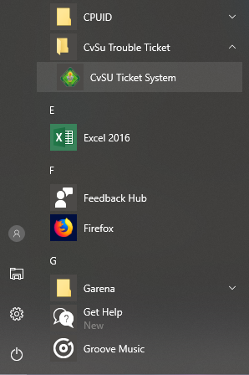

Figure 8. Application in desktop.

* 1. Click the icon to open the application.

**

Figure 9. Log-in form of Application.

1. Fill the log-in form.

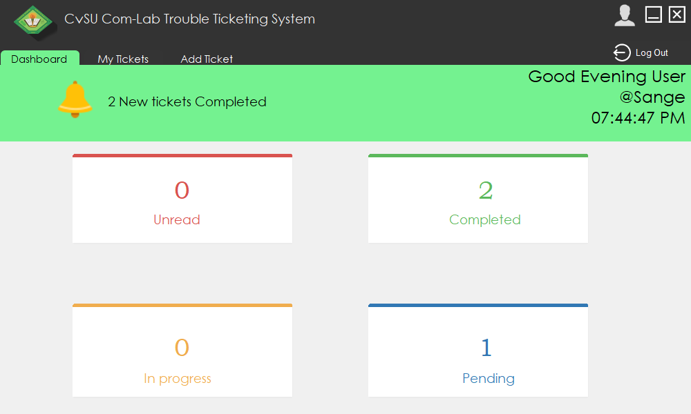

Figure 10. User dashboard.

1. If the user has logged-in, the user dashboard will show with the current progress of the ticket. The user can click the bell icon to see newly completed ticket. The user can also click the cards; it will direct them to My Tickets tab.

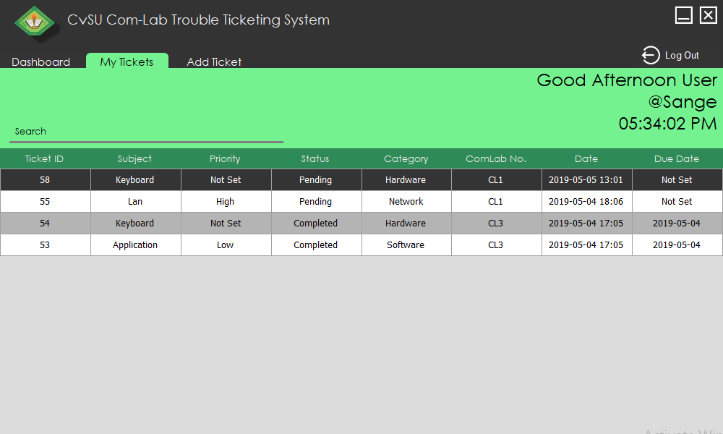

Figure 11. Admin Tickets.

1. The user can double click the tickets listed to see details of the tickets.

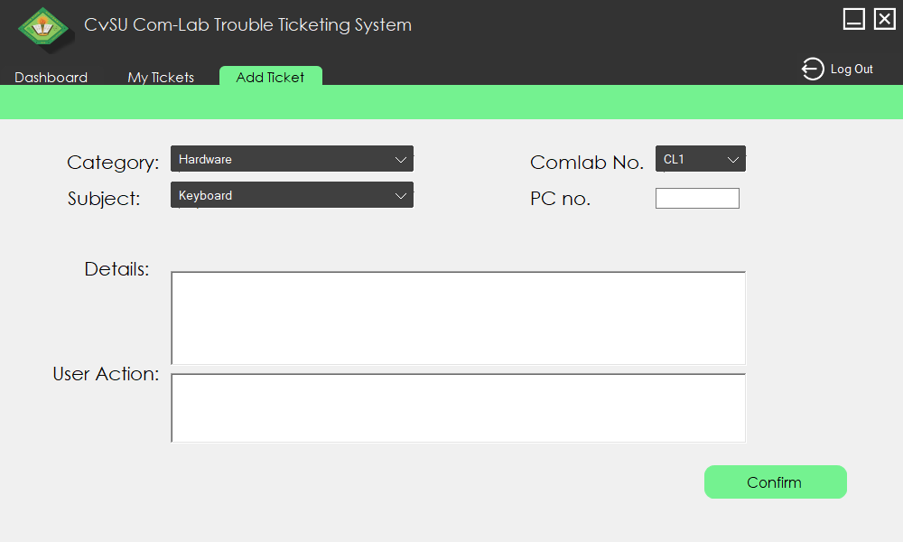

Figure 12. Add Ticket Form.

1. Once add ticket is clicked, it will show the add ticket tab where the user can add ticket.

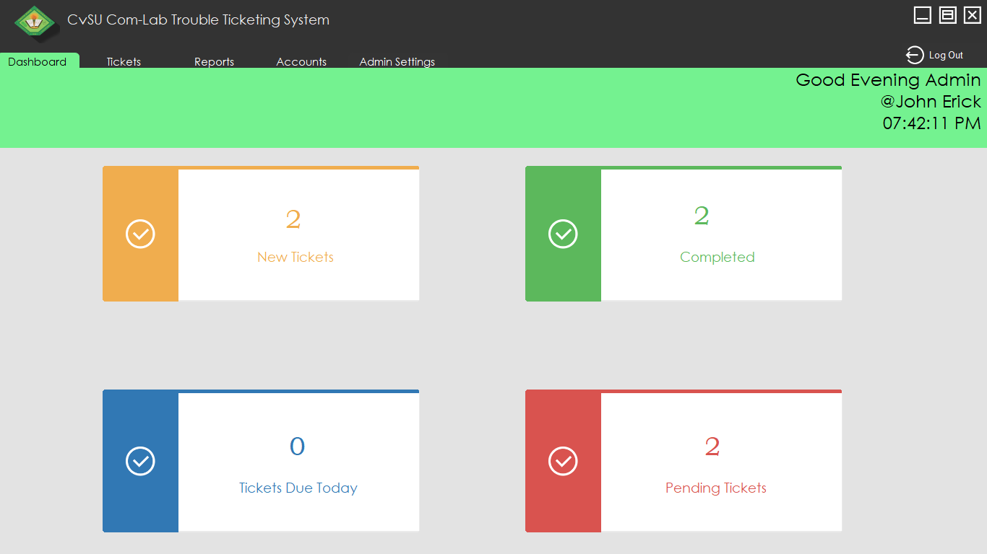

Figure 13. Admin dashboard.

1. This is the dashboard window of admin where he can see tickets sent by the user.

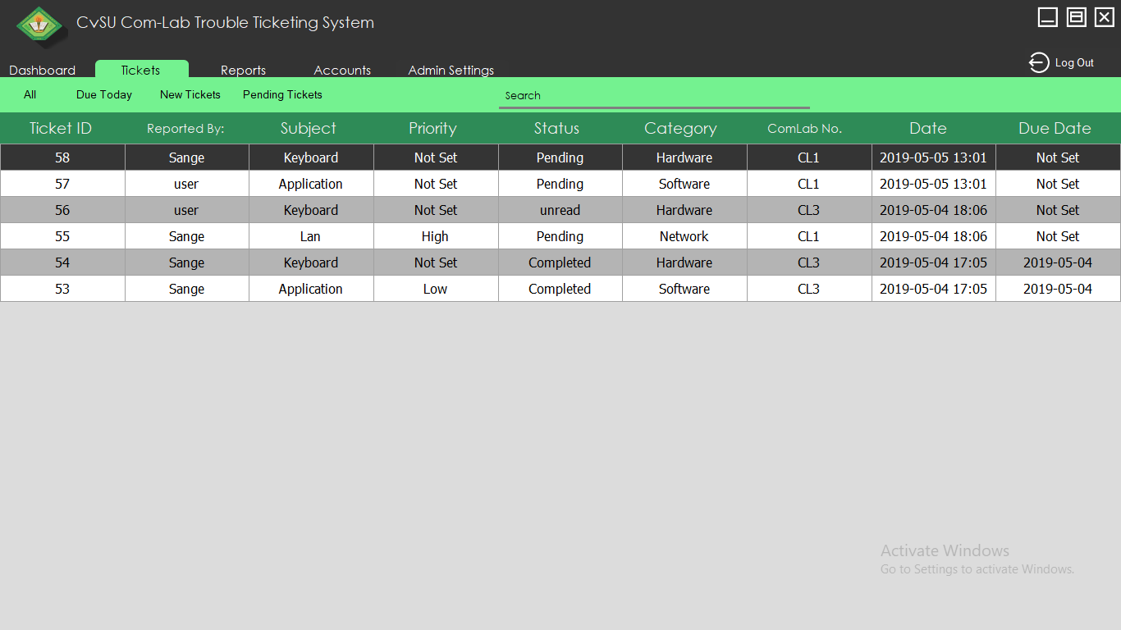

Figure 14. Admin Tickets.

1. This are the tickets sent by the user. It can be sort by searching in the search tab and also by clicking on the tabs.

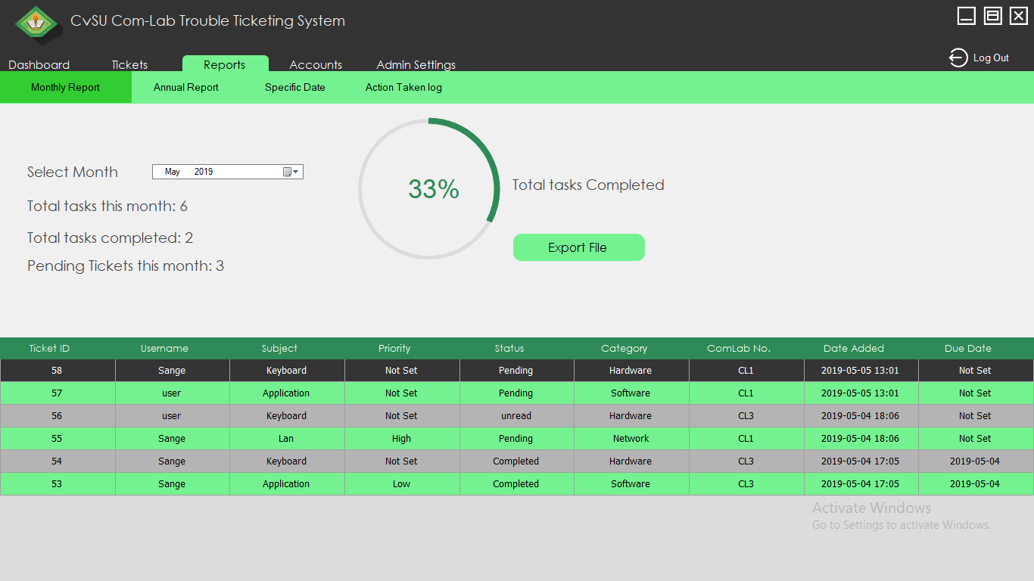

Figure 15. Reports.

1. The admin can choose monthly, annual and specific date report tab. It shows the details of the tickets in each tab. Reports can be exported in excel file format.

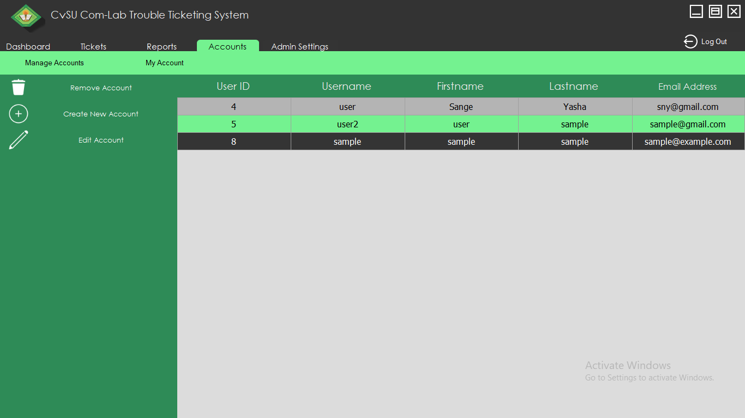

Figure 16. Accounts.

1. The admin can manage accounts in this tab.

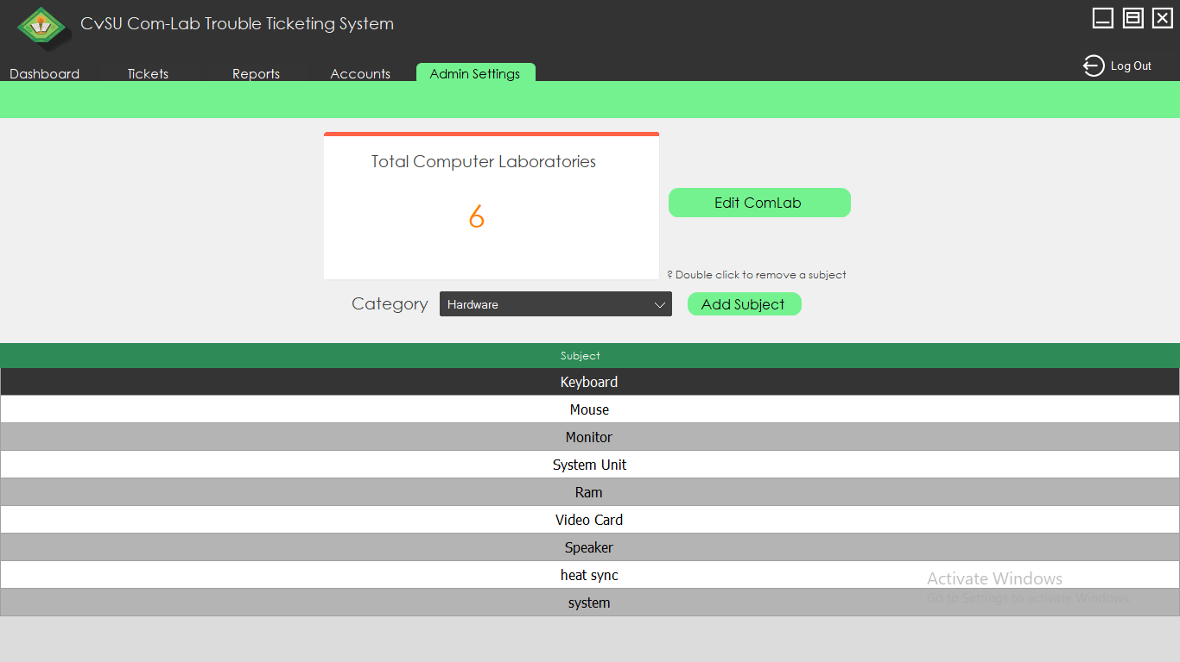

Figure 17. Admin Setting.

1. In this tab, the admin can change total computer laboratories and add subjects which the user can choose.

**SUMMARY, CONCLUSION AND RECOMMENDATION**

This section presents the summary of the software, evaluation, conclusion and recommendations of the authors for the future researchers. It concludes the final result of the evaluations conducted among 37 participants using the following criteria: functionality, reliability, usability, efficiency, maintainability and portability.

**Summary of Findings**

The study entitled Development of CvSU – SC Computer Laboratory Trouble Ticketing System is all about giving tickets to the admin for an easier way to report a problem between the user of computer laboratory of the campus and its IT staff. This study is for anyone who can possibly encounter a problem in the campus’s computer laboratory that needs an assistant of the IT staff. The application provides information about different issues in different computer laboratories of the university.

The developers used the Modified Waterfall Model in their software development process, which includes Planning, Analysis, Design, Implementation, and Maintenance. The system was develop using the following hardware specifications. Intel Core i5 processor, 8 GB Ram, and 240 GB SSD. For the software, the developers used Windows 10 64-Bit as the operating System, Visual Studio 2015 with Bunifu framework for the development of the application and design, and Microsoft Word 2016 for the documentations.

The developers conducted an evaluation of thirty-seven (37) respondents. These was divided into two (2), seven (7) Potential Users from the DIT faculty, and thirty (30) IT Experts from the industry.

The result of the evaluation showed that the application was Very Good as verified through Software Quality Standard evaluation. The result of the overall mean from the evaluation of the application was 4.2540 and the results proved that the application has been successfully constructed as design.

**Conclusion**

Based on the findings of the study, the following conclusions are drawn:

The developers successfully designed and develop a CvSU-SC Computer Laboratory Trouble Ticketing System with the following features, send tickets through a network, configurable tickets and track or organize issues. Therefore, the developers concluded that the developed application could make the communication between the users of the computers in laboratory and its IT staff better for faster actions to issues encountered in the laboratory. The developed application was also helpful for the IT staff of the campus to fix issues resources from the computer laboratory of the campus more easily.

**Recommendations**

Based on the findings and conclusions presented, the following recommendations are suggested:

It is recommended that the future developers improve the overall design of the system for better understandability of the system. It is also recommended to have save options for the reports generated that can be saved in a cloud storage, and back-up option for the whole system. This will help the technician to use the application effectively.

**REFERENCES**

Ahmed (2016).*Automated Queue Management System*. Retrieved from https://www.re

searchgate.net/publication/293593830_Automated_Queue_Management_System

Azeta et al., (2016). *Motivating Effective Ict Users’ Support Through Automated Mobile*

*Edu-Helpdesk System*. Retrieved from https://www.academia.edu/30984474/

EDU -HELPDESK_SYSTEM

Bober(2014)*Simulation for IT Service Desk Improvement*. Retrieved from https://www.

researchgate.net/publication/265591934_Simulation_for_IT_Service_Desk_Improvement

Brahma (2014). *Queuing Theory and Customer Satisfaction: A Review ofTerminology*

*Trends, and Applications to Hospital Practice.* Retrieved from https://pdfs.semanticscholar.org/1e87/7dd1f76d695089c9e9917e5c343abb2b7c2a.pdf

Dehinbo (2015).*Enhancing Service Desks’ Customers Relationship Management in a*

*South African Contact and e-Service Organizations*. Retrieved from www.iaeng. org/publication/WCECS2011/WCECS2011_pp72-78.pdf

Edward (1998). *A descriptive study of technical support within the Northern Illinois*

*University College of Education*. Retrieved from https://search.proquest.com /docview/304441019?accountid=173015

Hottum,Reuter (2014*). Ideas on Customer-oriented Queuing in Service Incident*

*Management*. Retrieved fromhttps://pdfs.semanticscholar.org/9270/23b41860 0690555a4c0ea29a4cba5d6ec39e.pdf

Jian Xu,RouyingHe,WubaiZhou,Tao Li. (2018).*Trouble Ticket Routing Models and*

*Their Applications*. Retrieved from https://ieeexplore.ieee.org/document/8249856

Jidin, Yusof, &Sutikno(2016). *Arduino Based Paperless Queue Management System*.

Retrieved from https://www.researchgate.net/publication/309463425_Arduino_Based_Paperless_Queue_Management_System

Kuzu (2015). *Analytical and empirical investigations of ticket queues: Implications for*

*system performance, customer perceptions and behavior*. Retrieved from https:// search.proquest.com/docview/854047587?accountid=173015

Masongsong, Damian (2016). *Help Desk management system*. Retrieved fromwww.

iaeng.org/publication/WCECS2016/WCECS2016_pp269-274.pdf

Pasalkar, Kharade, Nikam, &Jagade (2016)*Queue Control System Using Android*.

Retrieved from http://www.ierjournal.org/pupload/vol2iss6/Queue%20Control%20System%20Using%20Android.pdf

Xu,Gao,Ou (2017).*Service Performance Analysis and Improvement for a Ticket Queue*

*with Balking Customers*. Retrieved from https://papers.ssrn.com/sol3/papers.cfm? abstract_id=1962935